High Intensity Interval Training: Investigating the Impact of Different Running Intensities on Anaerobic Speed Reserve in Club Level Gaelic Football Players

Analysis report

Name:

Institution:

Date:

**List of Tables**

**Table 1: Playing Position Descriptive Statistics** 3

**Table 2: Demographic analysis** 4

**Table 3: Objective one descriptive statistics** 5

**Table 4: Descriptive statistics for ASR-40, MAS-120 and SIT** 5

**Table 5: ANOVA analysis table** 6

**Table 6: Multiple comparisons table** 7

**Table 7: Descriptive statistics table for training group MAS-120** 8

**Table 8: Grand mean** 9

**Table 9: Linear model for ASR against TD, HSRD, and sprinting distance for starters** 9

**Table 10: Linear model coefficients for starters (Game 1)** 10

**Table 11: Linear model coefficients for starters (Game 2)** 11

**Table 12:** **Linear model coefficients for starters (Game 3)** 11

**Table 13**: **Linear model for ASR against TD, HSRD, and sprinting distance for non-starters** 12

**Table 14:** **Linear model coefficients for non-starters** 12

**Table 15: Excluded variables from the model** 13

**Table 16: One way ANOVA for MAS-H, MAS-L, MSS-H, and MSS-L** 14

**Table 17: Multivariate tests table for the One way ANOVA** 14

**Table 18: Tests of Between-Subjects Effects** 16

**Table 19:** **Multiple Comparisons** 17

**Table 20: Model summary for linear model (ASR against %BF, Body mass)** 21

**Table 21: Model coefficients for linear model (MAS against %BF, Body mass)** 22

**Table 22:** **Model summary for linear model (MSS against %BF, Body mass)** 22

**Table 23:** **Model coefficients for linear model (MSS against %BF, Body mass)** 22

**Table 24:** **Model summary for linear model (ASR against %BF, Body mass)** 23

**Table 25:** **Model coefficients for linear model (ASR against %BF, Body mass)** 23

**List of Figures**

**Figure 1: Bar chart for playing position** 3

**Figure 2:** **Histograms for ASR-40, MAS-120 and SIT** 6

**Figure 3:** **Box plot for ASR-40, MAS-120 and SIT** 7

**Figure 6: MAS-H profile plot** 20

**Figure 7: MAS-L profile plot** 21

**Figure 8: MSS-H profile plot** 21

**Figure 9: MSS-L profile plot** 22

**Demographic characteristics table for participants**

**Table 1: Playing Position Descriptive Statistics**

|  |  |  |  |  |  |
| --- | --- | --- | --- | --- | --- |
| **Playing Position** | | | | | |
|  | | Frequency | Percent | Valid Percent | Cumulative Percent |
| Valid | Half Back | 11 | 30.6 | 30.6 | 30.6 |
| Full Back | 7 | 19.4 | 19.4 | 50.0 |
| Full Forward | 7 | 19.4 | 19.4 | 69.4 |
| Midfield | 5 | 13.9 | 13.9 | 83.3 |
| Half Forward | 5 | 13.9 | 13.9 | 97.2 |
| Wing Forward | 1 | 2.8 | 2.8 | 100.0 |
| Total | 36 | 100.0 | 100.0 |  |

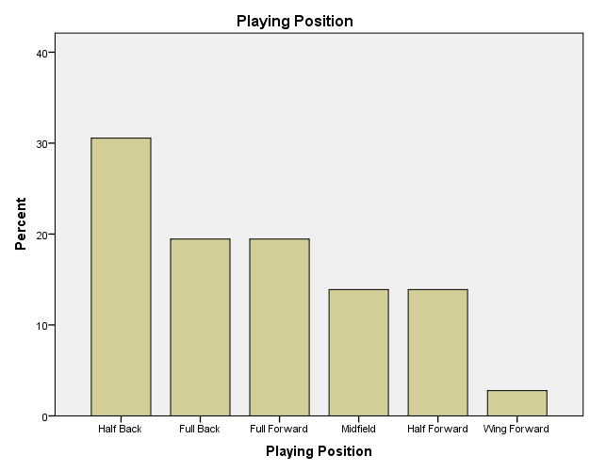

**Figure 1: Bar chart for playing position**

**Table 2: Demographic analysis**

|  |  |  |  |  |  |  |  |  |  |  |
| --- | --- | --- | --- | --- | --- | --- | --- | --- | --- | --- |
| **Descriptive Statistics** | | | | | | | | | | |
|  | N | Minimum | Maximum | Mean | Std. Deviation | Variance | Skewness | | Kurtosis | |
| Statistic | Statistic | Statistic | Statistic | Statistic | Statistic | Statistic | Std. Error | Statistic | Std. Error |
| Age | 36 | 19 | 31 | 23.67 | 3.696 | 13.657 | .600 | .393 | -.971 | .768 |
| Weight (kg) | 36 | 67.9000 | 93.9000 | 82.283333 | 7.0750063 | 50.056 | -.035 | .393 | -.726 | .768 |
| Height (cm) | 36 | 165 | 194 | 181.00 | 7.360 | 54.171 | -.181 | .393 | -.303 | .768 |
| BMI | 36 | 22.7 | 29.2 | 25.142 | 1.8207 | 3.315 | .704 | .393 | -.486 | .768 |
| % BF | 36 | 10.3500 | 26.0000 | 18.839722 | 4.5402659 | 20.614 | -.138 | .393 | -1.111 | .768 |
| Valid N (listwise) | 36 |  |  |  |  |  |  |  |  |  |

The oldest player was 31 years old, the youngest player was 19 years. The heaviest player was 93 kg, the lightest player was 67kg. the tallest player was 194cm and the shortest was a65cm.

1. **Evaluate the running speed performance (MAS-MSS) of sub-elite club level GF players to calculate the anaerobic speed reserve (MSS-MAS).**

**Analysis: Aggregation**

The players running speed performance improved from the test 2 to test 3. Similarly the ASR increased throughout to test 3. The descriptive statistics is shown below:

**Table 3: Objective one descriptive statistics**

|  |  |  |  |  |  |
| --- | --- | --- | --- | --- | --- |
| **Descriptive Statistics** | | | | | |
|  | N | Minimum | Maximum | Mean | Std. Deviation |
| MAS_Test 2 (m/s) | 36 | 3.4884 | 4.5455 | 4.021466 | .3297106 |
| MSS_Test 2 (m/s) | 36 | 7.7100 | 9.3500 | 8.368333 | .3411786 |
| ASR Test 2 (m/s) | 36 | 3.8345 | 5.6463 | 4.346867 | .3776050 |
| MAS_Test 3 (m/s) | 36 | 3.7129 | 4.6729 | 4.214861 | .2700175 |
| MSS_Test 3 (m/s) | 36 | 7.9200 | 9.4900 | 8.676944 | .2996457 |
| ASR Test 3 (m/s) | 36 | 4.0239 | 5.5939 | 4.462083 | .3001271 |
| Valid N (listwise) | 36 |  |  |  |  |

1. **Determine the impact of the six-week training intervention using different HIIT intensities (MAS-120%, ASR-40% and SIT) and their impact on ASR.**

**Analysis: One-way ANOVA**

**Table 4: Descriptive statistics for ASR-40, MAS-120 and SIT**

|  |  |  |  |  |  |  |  |  |  |
| --- | --- | --- | --- | --- | --- | --- | --- | --- | --- |
| **Descriptives** | | | | | | | | | |
|  | | N | Mean | Std. Deviation | Std. Error | 95% Confidence Interval for Mean | | Minimum | Maximum |
| Lower Bound | Upper Bound |
| ASR Test 2 (m/s) | ASR-40 | 12 | 4.288734 | .0933780 | .0269559 | 4.229405 | 4.348064 | 4.1506 | 4.4163 |
| SIT | 12 | 3.991336 | .0999728 | .0288596 | 3.927816 | 4.054856 | 3.8345 | 4.1265 |
| MAS-120 | 12 | 4.760531 | .3266695 | .0943014 | 4.552975 | 4.968087 | 4.5338 | 5.6463 |
| Total | 36 | 4.346867 | .3776050 | .0629342 | 4.219104 | 4.474630 | 3.8345 | 5.6463 |
| ASR Test 3 (m/s) | ASR-40 | 12 | 4.334210 | .1427135 | .0411978 | 4.243534 | 4.424886 | 4.0239 | 4.5497 |
| SIT | 12 | 4.316854 | .1526025 | .0440525 | 4.219895 | 4.413813 | 4.1316 | 4.6486 |
| MAS-120 | 12 | 4.735186 | .3474756 | .1003076 | 4.514410 | 4.955961 | 4.3046 | 5.5939 |
| Total | 36 | 4.462083 | .3001271 | .0500212 | 4.360535 | 4.563632 | 4.0239 | 5.5939 |

The training intensities had a positive impact on the ASR of players, the ASR improved throughout from test 2 to test 3, as shown in the table above.

**Table 5: ANOVA analysis table**

|  |  |  |  |  |  |  |
| --- | --- | --- | --- | --- | --- | --- |
| **ANOVA** | | | | | | |
|  | | Sum of Squares | df | Mean Square | F | Sig. |
| ASR Test 2 (m/s) | Between Groups | 3.611 | 2 | 1.805 | 43.182 | .000 |
| Within Groups | 1.380 | 33 | .042 |  |  |
| Total | 4.990 | 35 |  |  |  |
| ASR Test 3 (m/s) | Between Groups | 1.344 | 2 | .672 | 12.266 | .000 |
| Within Groups | 1.808 | 33 | .055 |  |  |
| Total | 3.153 | 35 |  |  |  |

Reporting on the ANOVA output: F (2, 35) = 43.182, p=0.000

The general rule of thumb is we reject the null hypothesis if “sig” or p<0.05, which is the case here. So we reject the null hypothesis that all means of ASR are equal for ASR-40, MAS-120 and SIT and conclude that the training intensities affected the ASR differently.

**Post Hoc Tests**

|  |  |  |  |  |  |  |  |
| --- | --- | --- | --- | --- | --- | --- | --- |
| **Multiple Comparisons** | | | | | | | |
| Tukey HSD | | | | | | | |
| Dependent Variable | (I) TrainingGroup_coded | (J) TrainingGroup_coded | Mean Difference (I-J) | Std. Error | Sig. | 95% Confidence Interval | |
| Lower Bound | Upper Bound |
| ASR Test 2 (m/s) | ASR-40 | SIT | .2973980* | .0834755 | .003 | .092566 | .502230 |
| MAS-120 | -.4717972* | .0834755 | .000 | -.676629 | -.266965 |
| SIT | ASR-40 | -.2973980* | .0834755 | .003 | -.502230 | -.092566 |
| MAS-120 | -.7691952* | .0834755 | .000 | -.974027 | -.564363 |
| MAS-120 | ASR-40 | .4717972* | .0834755 | .000 | .266965 | .676629 |
| SIT | .7691952* | .0834755 | .000 | .564363 | .974027 |
| ASR Test 3 (m/s) | ASR-40 | SIT | .0173558 | .0955667 | .982 | -.217145 | .251857 |
| MAS-120 | -.4009756* | .0955667 | .001 | -.635477 | -.166475 |
| SIT | ASR-40 | -.0173558 | .0955667 | .982 | -.251857 | .217145 |
| MAS-120 | -.4183314* | .0955667 | .000 | -.652832 | -.183830 |
| MAS-120 | ASR-40 | .4009756* | .0955667 | .001 | .166475 | .635477 |
| SIT | .4183314* | .0955667 | .000 | .183830 | .652832 |
| *. The mean difference is significant at the 0.05 level. | | | | | | | |

**Table 6: Multiple comparisons table**

Statistically significant mean difference are flagged with an asterisk (*) for instance the very first line tells us that the anaerobic speed reversal of players belonging to ASR-40 group was 0.297 m/s higher than those belonging to SIT, 0.472 m/s less than those belonging to MAS-120.

As a rule of thumb, **“Sig.” < 0.05 indicates a statistically significant difference** between two means.  
A [confidence interval](https://www.spss-tutorials.com/confidence-intervals/) *not* including zero means that a zero difference between these means in the population is unlikely.

1. **Compare running speed performance (MAS, MSS and ASR) between playing positions, which may aid coaches in tactical decision making and team selection in GF.**

**Table 7: Descriptive statistics table for training group MAS-120**

|  |  |  |  |  |
| --- | --- | --- | --- | --- |
| **Descriptive Statistics** | | | | |
|  | Playing_position | Mean | Std. Deviation | N |
| ASR Test 2 (km/hr) | Half Back | 17.486002 | 1.9008042 | 4 |
| Full Back | 17.617931 | 1.5204702 | 2 |
| Full Forward | 16.650071 | .2861032 | 4 |
| Midfield | 17.177860 | . | 1 |
| Half Forward | 16.768939 | . | 1 |
| Total | 17.143913 | 1.1844189 | 12 |
| ASR Test 3 (km/hr) | Half Back | 14.940492 | 1.0534996 | 4 |
| Full Back | 15.231693 | .7888205 | 2 |
| Full Forward | 14.085550 | .5039495 | 4 |
| Midfield | 14.210526 | . | 1 |
| Half Forward | 14.713896 | . | 1 |
| Total | 14.624331 | .8085747 | 12 |
| MAS Test 2 (km/hr) | Half Back | 14.081809 | 1.2903644 | 4 |
| Full Back | 14.443968 | .8454373 | 2 |
| Full Forward | 13.219621 | .5394971 | 4 |
| Midfield | 13.202934 | . | 1 |
| Half Forward | 13.740458 | . | 1 |
| Total | 13.753087 | .9249615 | 12 |
| MAS Test 3(km/hr) | Half Back | 14.940492 | 1.0534996 | 4 |
| Full Back | 15.231693 | .7888205 | 2 |
| Full Forward | 14.085550 | .5039495 | 4 |
| Midfield | 14.210526 | . | 1 |
| Half Forward | 14.713896 | . | 1 |
| Total | 14.624331 | .8085747 | 12 |
| MSS Test 2 (km/hr) | Half Back | 31.635000 | 1.7469894 | 4 |
| Full Back | 30.816000 | .9164104 | 2 |
| Full Forward | 30.060000 | .4838843 | 4 |
| Midfield | 31.824000 | . | 1 |
| Half Forward | 30.456000 | . | 1 |
| Total | 30.891000 | 1.2338229 | 12 |
| MSS Test 3 (km/hr) | Half Back | 32.382000 | 1.5657586 | 4 |
| Full Back | 31.644000 | .1018234 | 2 |
| Full Forward | 30.861000 | .7184233 | 4 |
| Midfield | 31.896000 | . | 1 |
| Half Forward | 31.896000 | . | 1 |
| Total | 31.671000 | 1.1144814 | 12 |

From the results above the ASR reduces from test two to test three. The MAS increases from test two to test three. The MSS increases from test two to test three.

**Table 8: Grand mean**

|  |  |  |  |  |
| --- | --- | --- | --- | --- |
| **Grand Mean** | | | | |
| Dependent Variable | Mean | Std. Error | 95% Confidence Interval | |
| Lower Bound | Upper Bound |
| ASR Test 2 (km/hr) | 17.140 | .479 | 16.007 | 18.273 |
| ASR Test 3 (km/hr) | 14.636 | .284 | 13.964 | 15.309 |
| MAS Test 2 (km/hr) | 13.738 | .336 | 12.943 | 14.532 |
| MAS Test 3(km/hr) | 14.636 | .284 | 13.964 | 15.309 |
| MSS Test 2 (km/hr) | 30.958 | .428 | 29.946 | 31.971 |
| MSS Test 3 (km/hr) | 31.736 | .391 | 30.811 | 32.660 |

1. **Quantify, the training load of three competitive games with reference to TD, (HSRD ≥17 km/h), and sprint distance (>22 km/h), to investigate if the additional volume impacted ASR, between starters and non-starters.**

**Analysis: Multiple linear regression**

**Impact of TD, (HSRD ≥17 km/h), and sprint distance (>22 km/h) to ASR for Starter players**

**Table 9: Linear model for ASR against TD, HSRD, and sprinting distance for starters**

|  |  |  |  |  |
| --- | --- | --- | --- | --- |
| **Model Summary** | | | | |
| Model | R | R Square | Adjusted R Square | Std. Error of the Estimate |
| 1 | .630a | .397 | .170 | 1.4395199 |
| a. Predictors: (Constant), SprintDistance_game1, TD_game1, HSRD_game1 | | | | |

**Table 10: Linear model coefficients for starters (Game 1)**

|  |  |  |  |  |  |  |
| --- | --- | --- | --- | --- | --- | --- |
| **Coefficientsa** | | | | | | |
| Model | | Unstandardized Coefficients | | Standardized Coefficients | t | Sig. |
| B | Std. Error | Beta |
| 1 | (Constant) | 20.862 | 2.320 |  | 8.994 | .000 |
| TD_game1 | -.544 | .488 | -.427 | -1.115 | .297 |
| HSRD_game1 | .002 | .003 | .242 | .557 | .593 |
| SprintDistance_game1 | -.012 | .011 | -.455 | -1.081 | .311 |
| a. Dependent Variable: ASR1_kmhr | | | | | | |

In the first game the players Total distance covered and sprinting distance had a negative impact on ASR. The more distance they covered the more their ASR decreased. On the other hand, the High speed running distances (HSRD) had a positive impact on ASR, the more HSRD a player attained the more their ASR increased. If a player’s TD increases by 100% the ASR would reduce by 54%.

TD had a negative impact on ASR such that, one kilometre increase in Total distance (TD) causes a decrease in ASR by 0.544. HSRD had a positive impact on ASR. As HSRD increases by 1km/hr then ASR increases by 0.002. The sprinting distance had a negative impact on ASR, when sprint distance increases by 1km/hr the ASR will reduce by 0.012km/hr.

**Table 11: Linear model coefficients for starters (Game 2)**

|  |  |  |  |  |  |  |
| --- | --- | --- | --- | --- | --- | --- |
| **Coefficientsa** | | | | | | |
| Model | | Unstandardized Coefficients | | Standardized Coefficients | t | Sig. |
| B | Std. Error | Beta |
| 1 | (Constant) | 23.028 | 3.673 |  | 6.269 | .000 |
| TD (km) (Total Distance) | -.420 | .793 | -.199 | -.530 | .608 |
| HSRD (M) (&gt;17km/hr) | -.008 | .006 | -.707 | -1.348 | .208 |
| Sprint Distance (M) (&gt;22 km/hr) | .013 | .012 | .433 | 1.079 | .306 |
| a. Dependent Variable: ASR2_Kmhr | | | | | | |

The player performance in the second game was different as the Total distance and High speed running distance had a negative impact on the ASR, while sprinting distance had a positive impact on ASR. However in game two the players improved in terms of the decreasing negative impact of TD on ASR whereby their Total distance negative effect on ASR reduced to 0.42 from 0.544 in game one. In game two the ASR of a player will reduce by 42% when their Total distance is increased by 100%, as compared to game one where the ASR reduced by 54%. In game two the ASR of a player will reduce by 0.8% when their HSRD increases by 100% as compared to game one the ASR increased by 0.2% when HSRD increased by 100%. A 100% increase in Sprinting distance causes a 1.3% increases in ASR.

Generally game two led to a 13.9% cumulative improvement on ASR. TD (0.544-0.42) + Sprinting distance (0.012+0.013) – HSRD (0.002+0.008) = 0.139

**Table 12:** **Linear model coefficients for starters (Game 3)**

|  |  |  |  |  |  |  |
| --- | --- | --- | --- | --- | --- | --- |
| **Coefficientsa** | | | | | | |
| Model | | Unstandardized Coefficients | | Standardized Coefficients | t | Sig. |
| B | Std. Error | Beta |
| 1 | (Constant) | 19.100 | 3.211 |  | 5.948 | .000 |
| TD (km) (Total Distance) | -.409 | .571 | -.221 | -.716 | .490 |
| HSRD (M) (&gt;17km/hr) | -.006 | .004 | -.621 | -1.580 | .145 |
| Sprint Distance (M) (&gt;22 km/hr) | .024 | .010 | .787 | 2.452 | .034 |
| a. Dependent Variable: ASR3_Kmhr | | | | | | |

The total distance negative impact on ASR decreased from 0.42 to 0.409 (1.1% decrease) HSRD negative impact also reduced from 0.008 to 0.006 (0.2% decrease) the positive impact of sprinting distance increase from 0.013 to 0.024 (1.1% increase). Generally the positive impact of TD, HSRD, and sprinting distance on ASR improved by 2.4% in game three. Thus we conclude that gradually as the players continued playing from game one to three their performance improved.

**Impact of TD, (HSRD ≥17 km/h), and sprint distance (>22 km/h) to ASR for Non-Starter players**

**Table 13**: **Linear model for ASR against TD, HSRD, and sprinting distance for non-starters**

|  |  |  |  |  |  |  |  |  |  |
| --- | --- | --- | --- | --- | --- | --- | --- | --- | --- |
| **Model Summary** | | | | | | | | | |
| Model | R | R Square | Adjusted R Square | Std. Error of the Estimate | Change Statistics | | | | |
| R Square Change | F Change | df1 | df2 | Sig. F Change |
| 1 | 1.000a | 1.000 | . | . | 1.000 | . | 1 | 0 | . |
| a. Predictors: (Constant), SprintDistance_game1 | | | | | | | | | |

**Table 14:** **Linear model coefficients for non-starters**

|  |  |  |  |  |  |  |
| --- | --- | --- | --- | --- | --- | --- |
| **Coefficientsa** | | | | | | |
| Model | | Unstandardized Coefficients | | Standardized Coefficients | t | Sig. |
| B | Std. Error | Beta |
| 1 | (Constant) | 7.906 | .000 |  | . | . |
| SprintDistance_game1 | -.012 | .000 | -1.000 | . | . |
| a. Dependent Variable: ASRTest1ms | | | | | | |

The output shows that model was unable to analyze the impact of the predictor variables because most of the data was missing. Hence the constant (intercept) and the sprinting distance were only shown.

**Table 15: Excluded variables from the model**

|  |  |  |  |  |  |  |
| --- | --- | --- | --- | --- | --- | --- |
| **Excluded Variablesa** | | | | | | |
| Model | | Beta In | t | Sig. | Partial Correlation | Collinearity Statistics |
| Tolerance |
| 1 | TD_game1 | .b | . | . | . | .000 |
| HSRD_game1 | .b | . | . | . | .000 |
| a. Dependent Variable: ASRTest1ms | | | | | | |
| b. Predictors in the Model: (Constant), SprintDistance_game1 | | | | | | |

The table above shows the variables that are expected in the model and most parameters are empty due to insufficient data to perform the analysis.

1. **Evaluate the impact that different training intensities had on participants who displayed, MAS-H, MAS-L, MSS-H and MSS-L. Was there a larger positive effect for players who had a lower MAS and MSS compared to players who had a higher MAS and MSS?**

**Analysis: One-way MANOVA**

**Table 16: One way ANOVA for MAS-H, MAS-L, MSS-H, and MSS-L**

|  |  |  |  |  |
| --- | --- | --- | --- | --- |
| **Descriptive Statistics** | | | | |
|  | TrainingGroup_coded | Mean | Std. Deviation | N |
| MAS_H | ASR-40 | 4.2000 | .23314 | 12 |
| SIT | 4.3823 | .26639 | 12 |
| MAS-120 | 4.0623 | .22460 | 12 |
| Total | 4.2149 | .27002 | 36 |
| MAS_L | ASR-40 | 3.8629 | .32085 | 12 |
| SIT | 4.1735 | .27999 | 12 |
| MAS-120 | 3.6981 | .26707 | 12 |
| Total | 3.9115 | .34550 | 36 |
| MSS_H | ASR-40 | 8.5342 | .32191 | 12 |
| SIT | 8.6992 | .21815 | 12 |
| MAS-120 | 8.7975 | .30958 | 12 |
| Total | 8.6769 | .29965 | 36 |
| MSS_L | ASR-40 | 8.1533 | .28893 | 12 |
| SIT | 8.0700 | .29766 | 12 |
| MAS-120 | 8.4100 | .28419 | 12 |
| Total | 8.2111 | .31780 | 36 |

**Table 17: Multivariate tests table for the One way ANOVA**

|  |  |  |  |  |  |  |  |
| --- | --- | --- | --- | --- | --- | --- | --- |
| **Multivariate Testsa** | | | | | | | |
| Effect | | Value | F | Hypothesis df | Error df | Sig. | Partial Eta Squared |
| Intercept | Pillai's Trace | .999 | 14457.085b | 4.000 | 30.000 | .000 | .999 |
| Wilks' Lambda | .001 | 14457.085b | 4.000 | 30.000 | .000 | .999 |
| Hotelling's Trace | 1927.611 | 14457.085b | 4.000 | 30.000 | .000 | .999 |
| Roy's Largest Root | 1927.611 | 14457.085b | 4.000 | 30.000 | .000 | .999 |
| TrainingGroup_coded | Pillai's Trace | .984 | 7.506 | 8.000 | 62.000 | .000 | .492 |
| Wilks' Lambda | .166 | 10.919b | 8.000 | 60.000 | .000 | .593 |
| Hotelling's Trace | 4.128 | 14.964 | 8.000 | 58.000 | .000 | .674 |
| Roy's Largest Root | 3.896 | 30.196c | 4.000 | 31.000 | .000 | .796 |
| a. Design: Intercept + TrainingGroup_coded | | | | | | | |
| b. Exact statistic | | | | | | | |
| c. The statistic is an upper bound on F that yields a lower bound on the significance level. | | | | | | | |

The **Multivariate Tests** table is where we find the actual result of the one-way MANOVA. You need to look at the second Effect, labelled "**TrainingGroup_coded**", and the Wilks' Lambda row (highlighted in yellow). To determine whether the one-way MANOVA was statistically significant you need to look at the "**Sig.**" column. We can see from the table that we have a "**Sig.**" value of .000, which means p < .0005. Therefore, we can conclude that running speed performance (MAS-H, MAS-L, MSS-H, and MSS-L) was significantly dependent on training intensities (p < .0005).

**Table 18: Tests of Between-Subjects Effects**

|  |  |  |  |  |  |  |  |
| --- | --- | --- | --- | --- | --- | --- | --- |
| **Tests of Between-Subjects Effects** | | | | | | | |
| Source | Dependent Variable | Type III Sum of Squares | df | Mean Square | F | Sig. | Partial Eta Squared |
| Corrected Model | MAS_H | .618a | 2 | .309 | 5.277 | .010 | .242 |
| MAS_L | 1.399b | 2 | .699 | 8.303 | .001 | .335 |
| MSS_H | .425c | 2 | .212 | 2.580 | .091 | .135 |
| MSS_L | .754d | 2 | .377 | 4.471 | .019 | .213 |
| Intercept | MAS_H | 639.542 | 1 | 639.542 | 10915.717 | .000 | .997 |
| MAS_L | 550.792 | 1 | 550.792 | 6539.726 | .000 | .995 |
| MSS_H | 2710.417 | 1 | 2710.417 | 32912.677 | .000 | .999 |
| MSS_L | 2427.204 | 1 | 2427.204 | 28799.017 | .000 | .999 |
| TrainingGroup_coded | MAS_H | .618 | 2 | .309 | 5.277 | .010 | .242 |
| MAS_L | 1.399 | 2 | .699 | 8.303 | .001 | .335 |
| MSS_H | .425 | 2 | .212 | 2.580 | .091 | .135 |
| MSS_L | .754 | 2 | .377 | 4.471 | .019 | .213 |
| Error | MAS_H | 1.933 | 33 | .059 |  |  |  |
| MAS_L | 2.779 | 33 | .084 |  |  |  |
| MSS_H | 2.718 | 33 | .082 |  |  |  |
| MSS_L | 2.781 | 33 | .084 |  |  |  |
| Total | MAS_H | 642.094 | 36 |  |  |  |  |
| MAS_L | 554.970 | 36 |  |  |  |  |
| MSS_H | 2713.560 | 36 |  |  |  |  |
| MSS_L | 2430.739 | 36 |  |  |  |  |
| Corrected Total | MAS_H | 2.552 | 35 |  |  |  |  |
| MAS_L | 4.178 | 35 |  |  |  |  |
| MSS_H | 3.143 | 35 |  |  |  |  |
| MSS_L | 3.535 | 35 |  |  |  |  |
| a. R Squared = .242 (Adjusted R Squared = .196) | | | | | | | |
| b. R Squared = .335 (Adjusted R Squared = .294) | | | | | | | |
| c. R Squared = .135 (Adjusted R Squared = .083) | | | | | | | |
| d. R Squared = .213 (Adjusted R Squared = .166) | | | | | | | |

To determine how the dependent variables differ for the independent variable, we need to look at the **Tests of Between-Subjects Effects** table (highlighted in yellow):

We can see from this table that training intensity (training group) has a statistically significant effect on MAS-H (F (2, 33) = 5.277; p < 0.05; partial η2 = 0.242), MAS-L (F (2, 33) = 8.303; p < 0.05; partial η2 = 0.335) MSS-H (F (2, 33) = 2.580; p > 0.05; partial η2 = 0.135) and MSS-L (F (2, 33) = 4.471; p < 0.05; partial η2 = 0.213). It is important to note that you should make an alpha correction to account for multiple ANOVAs being run, such as a Bonferroni correction. As such, in this case, we accept statistical significance at p < .025.

**Table 19:** **Multiple Comparisons**

|  |  |  |  |  |  |  |  |
| --- | --- | --- | --- | --- | --- | --- | --- |
| **Multiple Comparisons** | | | | | | | |
| Tukey HSD | | | | | | | |
| Dependent Variable | (I) TrainingGroup_coded | (J) TrainingGroup_coded | Mean Difference (I-J) | Std. Error | Sig. | 95% Confidence Interval | |
| Lower Bound | Upper Bound |
| MAS_H | ASR-40 | SIT | -.1824 | .09882 | .171 | -.4248 | .0601 |
| MAS-120 | .1376 | .09882 | .356 | -.1048 | .3801 |
| SIT | ASR-40 | .1824 | .09882 | .171 | -.0601 | .4248 |
| MAS-120 | .3200* | .09882 | .008 | .0775 | .5625 |
| MAS-120 | ASR-40 | -.1376 | .09882 | .356 | -.3801 | .1048 |
| SIT | -.3200* | .09882 | .008 | -.5625 | -.0775 |
| MAS_L | ASR-40 | SIT | -.3106* | .11848 | .034 | -.6014 | -.0199 |
| MAS-120 | .1648 | .11848 | .357 | -.1260 | .4555 |
| SIT | ASR-40 | .3106* | .11848 | .034 | .0199 | .6014 |
| MAS-120 | .4754* | .11848 | .001 | .1847 | .7661 |
| MAS-120 | ASR-40 | -.1648 | .11848 | .357 | -.4555 | .1260 |
| SIT | -.4754* | .11848 | .001 | -.7661 | -.1847 |
| MSS_H | ASR-40 | SIT | -.1650 | .11716 | .348 | -.4525 | .1225 |
| MAS-120 | -.2633 | .11716 | .078 | -.5508 | .0241 |
| SIT | ASR-40 | .1650 | .11716 | .348 | -.1225 | .4525 |
| MAS-120 | -.0983 | .11716 | .682 | -.3858 | .1891 |
| MAS-120 | ASR-40 | .2633 | .11716 | .078 | -.0241 | .5508 |
| SIT | .0983 | .11716 | .682 | -.1891 | .3858 |
| MSS_L | ASR-40 | SIT | .0833 | .11852 | .763 | -.2075 | .3742 |
| MAS-120 | -.2567 | .11852 | .092 | -.5475 | .0342 |
| SIT | ASR-40 | -.0833 | .11852 | .763 | -.3742 | .2075 |
| MAS-120 | -.3400* | .11852 | .019 | -.6308 | -.0492 |
| MAS-120 | ASR-40 | .2567 | .11852 | .092 | -.0342 | .5475 |
| SIT | .3400* | .11852 | .019 | .0492 | .6308 |
| Based on observed means.  The error term is Mean Square(Error) = .084. | | | | | | | |
| *. The mean difference is significant at the .05 level. | | | | | | | |

The table above shows that for mean scores for MAS-H were statistically significantly different between SIT and MAS-120 (p < 0.05), but not between ASR-40 & SIT (p = 0.171), and ASR-40 & MAS-120 (*p*=0.356).

Mean MAS-L scores were statistically significantly different between ASR-40 & SIT (p =0.034), and SIT & MAS-120 (p =0.01), but not between ASR-40 & MAS-120 (p = 0.357).

Mean MSS-H were not statistically significantly different between ASR-40 & SIT (p=0.348), ASR-40 & MAS-120(p=0.078), and SIT & MAS-120 (p=0.682).

Mean MSS-L were statistically significantly different between SIT & MAS-120 (p=0.019) but not between ASR-40 & SIT (p=0.763), and ASR-40 & MAS-120 (p=0.092).

These differences can be easily visualized by the plots generated by this procedure, as shown below:

**Profile Plots**

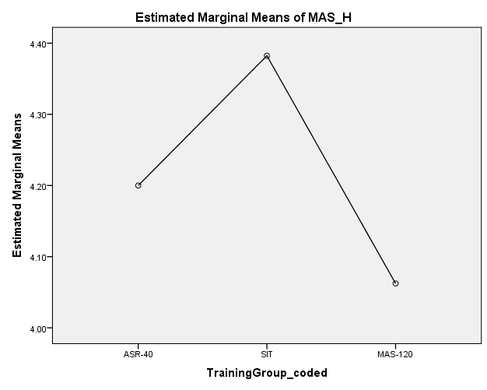

**Figure 6: MAS-H profile plot**

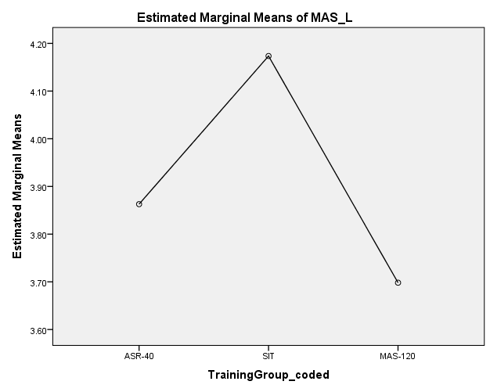

**Figure 7: MAS-L profile plot**

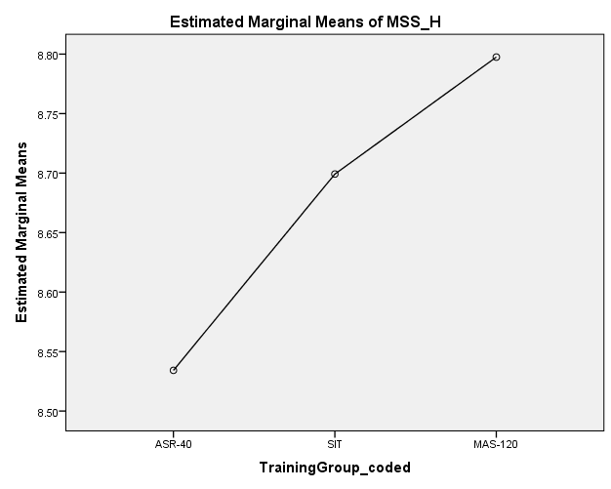

**Figure 8: MSS-H profile plot**

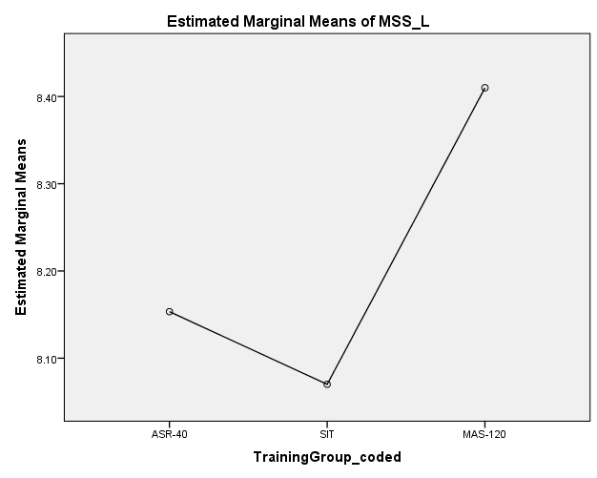

**Figure 9: MSS-L profile plot**

1. **What impact did %BF and Body Mass (kg) have on MAS, MSS and ASR? E.g.**

**Was there a difference in MAS, MSS and ASR between players with higher and lower %BF.**

**Analysis: Multiple linear regression**

**Impact of %BF and Body Mass on MAS (Maximal aerobic speed)**

**Table 20: Model summary for linear model (ASR against %BF, Body mass)**

|  |  |  |  |  |  |  |  |  |  |
| --- | --- | --- | --- | --- | --- | --- | --- | --- | --- |
| **Model Summary** | | | | | | | | | |
| Model | R | R Square | Adjusted R Square | Std. Error of the Estimate | Change Statistics | | | | |
| R Square Change | F Change | df1 | df2 | Sig. F Change |
| 1 | .268a | .072 | .016 | .3427930 | .072 | 1.277 | 2 | 33 | .292 |
| a. Predictors: (Constant), % BF, BMI | | | | | | | | | |

**Table 21: Model coefficients for linear model (MAS against %BF, Body mass)**

|  |  |  |  |  |  |  |
| --- | --- | --- | --- | --- | --- | --- |
| **Coefficientsa** | | | | | | |
| Model | | Unstandardized Coefficients | | Standardized Coefficients | T | Sig. |
| B | Std. Error | Beta |
| 1 | (Constant) | 4.804 | .864 |  | 5.558 | .000 |
| BMI | -.026 | .040 | -.140 | -.655 | .517 |
| % BF | -.012 | .016 | -.158 | -.743 | .463 |
| a. Dependent Variable: MAS_Test 1 (m/s) | | | | | | |

The BMI had a negative impact on MAS, one unit increase BMI leads to a decrease in MAS by 0.026. The %BF had a negative impact on MAS, one unit increase in %BF causes a decrease in MAS by 0.012

**Impact of %BF and Body Mass on MSS (Maximal sprinting speed)**

**Table 22:** **Model summary for linear model (MSS against %BF, Body mass)**

|  |  |  |  |  |  |  |  |  |  |
| --- | --- | --- | --- | --- | --- | --- | --- | --- | --- |
| **Model Summary** | | | | | | | | | |
| Model | R | R Square | Adjusted R Square | Std. Error of the Estimate | Change Statistics | | | | |
| R Square Change | F Change | df1 | df2 | Sig. F Change |
| 1 | .201a | .041 | -.018 | .3205878 | .041 | .697 | 2 | 33 | .505 |
| a. Predictors: (Constant), % BF, BMI | | | | | | | | | |

**Table 23:** **Model coefficients for linear model (MSS against %BF, Body mass)**

|  |  |  |  |  |  |  |
| --- | --- | --- | --- | --- | --- | --- |
| **Coefficientsa** | | | | | | |
| Model | | Unstandardized Coefficients | | Standardized Coefficients | t | Sig. |
| B | Std. Error | Beta |
| 1 | (Constant) | 9.082 | .808 |  | 11.235 | .000 |
| BMI | -.034 | .038 | -.196 | -.904 | .373 |
| % BF | -.001 | .015 | -.009 | -.040 | .968 |
| a. Dependent Variable: MSS_Test 1 (m/s) | | | | | | |

The BMI had a negative impact on MSS, one unit increase BMI leads to a decrease in MSS by 0.034. The %BF had a negative impact on MSS, one unit increase in %BF causes a decrease in MSS by 0.001.

**Impact of %BF and Body Mass on ASR (Anaerobic Speed Reverse)**

**Table 24:** **Model summary for linear model (ASR against %BF, Body mass)**

|  |  |  |  |  |  |  |  |  |  |
| --- | --- | --- | --- | --- | --- | --- | --- | --- | --- |
| **Model Summary** | | | | | | | | | |
| Model | R | R Square | Adjusted R Square | Std. Error of the Estimate | Change Statistics | | | | |
| R Square Change | F Change | df1 | df2 | Sig. F Change |
| 1 | .117a | .014 | -.046 | .3897099 | .014 | .230 | 2 | 33 | .796 |
| a. Predictors: (Constant), % BF, BMI | | | | | | | | | |

**Table 25:** **Model coefficients for linear model (ASR against %BF, Body mass)**

|  |  |  |  |  |  |  |
| --- | --- | --- | --- | --- | --- | --- |
| **Coefficientsa** | | | | | | |
| Model | | Unstandardized Coefficients | | Standardized Coefficients | t | Sig. |
| B | Std. Error | Beta |
| 1 | (Constant) | 4.278 | .983 |  | 4.353 | .000 |
| BMI | -.008 | .046 | -.037 | -.168 | .868 |
| % BF | .011 | .018 | .136 | .621 | .539 |
| a. Dependent Variable: ASR Test 1 (m/s) | | | | | | |

The BMI had a negative impact on ASR, one unit increase BMI leads to a decrease in ASR by 0.008. The %BF had a positive impact on ASR, one unit increase in %BF causes an increase in ASR by 0.011.